Creation of Bzone_Transit_Service.csv
March 10, 2026
Definition of the Input File
Bzone_transit_service.csv is defined as the “aggregate frequency of transit service within 0.25 miles of block group boundary per hour during evening peak period” and is based on attribute D4c within the EPA Smart Location Database. This is one of two key transit inputs in VisionEval (see https://visioneval.github.io/docs/model-inputs.html).
These values are shown below for three bzones: 515400010001 (an urban area near Charlottesville’s downtown pedestrian mall) with large amounts of employment, 510030107021 (a suburban area near Route 29 in Albemarle County with some employment), and 510030110004 (a rural residential area in Albemarle County). Not surprisingly, one has greater transit service in the most urban area with the rural area having none.
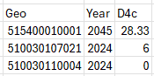
For year 2045, values are presumed to be the same as for year 2024.
Possible Scenario
As noted in the document Task 7.2 Simplified Scenario Development guide, available at A Playbook for Simplified Approaches for Creating Scenarios in VisionEval, two related files should be manipulated: bzone_transit_service.csv (this one) and marea_transit_service.csv (one that indicates supply). In sum, one can ask “How would travel behavior change if the availability of transit were double what it is today? This topic explores the question of increasing the overall supply of transit options to a region. Transit considers both the extent to which the service is available (coverage) and the frequency of that service.” The guidance notes that while this file shows availability at the bzone level, one should also modify marea_transit_service.csv which shows total transit supply—that is, change both in tandem.
Method Used for Virginia
Version 3 of the Smart Location database (updated in 2025) was obtained from the U.S. EPA (2025) and overlaid with the 5,963 block groups in Virginia and was treated as the 2024 base year. The 2045 forecast year presumes that there will be no change in transit service frequency. The documentation available with this data source from EPA clarifies that D4c is “expressed as service frequency per hour of service” where the peak period is 4 pm – 7 pm.
There was not a perfect alignment between the zones used EPA for Virginia (roughly 5,332) and the 5,963 block groups used in Virginia in 2024. For example, Figure 1 shows that a highlighted block group from 2024 for Virginia. In the EPA database, this block group is not evident by itself but rather is a part of the larger block group. Accordingly, GIS processing (in this case, a spatial join) used the mean value of EPA attribute D4c for the Virginia 2024 block groups for year 2024. In addition, because EPA uses a value of “-99999” for attributes which have no transit service, such values were set to a frequency of zero.
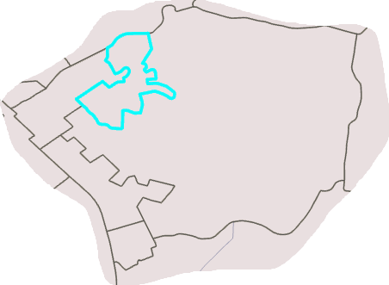
Figure 1. The smaller highlighted zone is in the VisionEval larger nonhlighlighted zone are
For year 2045, the same transit frequencies for year 2024 were presumed as a base case—e.g., not improvement or reduction in transit service frequency.
Sources
VisionEval.org. User’s Guide: Model Inputs. https://visioneval.github.io/docs/model-inputs.html#verspm-inputs. Accessed February 3, 2026.
U.S. Environmental Protection Agency. Smart Location Database, Washington, D.C., February 25, 2025. https://catalog.data.gov/dataset/smart-location-database8. Accessed February 3, 2026.

SCRAP Material for John
- Writeup and Excel locations: \\501-RC-NAS1\Users\John.Miller\LT\Team_Projects\VE_STudio\
- New file downloaded February 3, 2026: https://catalog.data.gov/dataset/smart-location-database8
  - Screenshot of new file that I downloaded
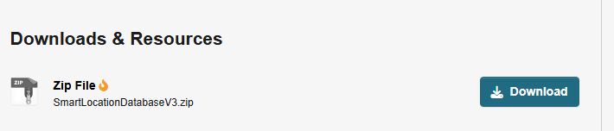
  - Web page where I downloaded it
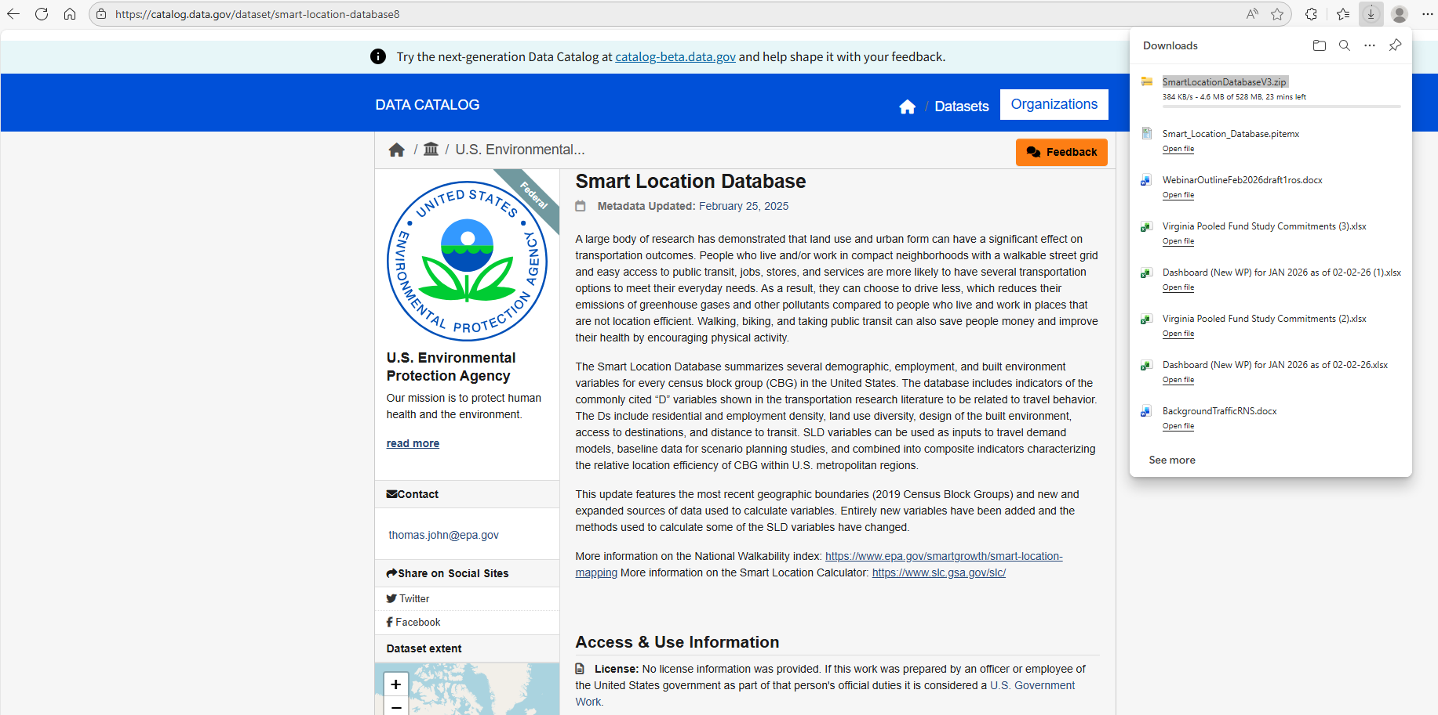
  - Evidence that file is huge!
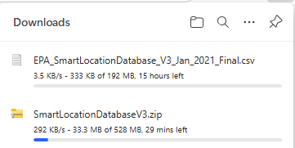
- EPA contat: thomas.john@epa.gov
- What VE documentation says
  - Location: https://visioneval.github.io/docs/model-inputs.html#verspm-inputs
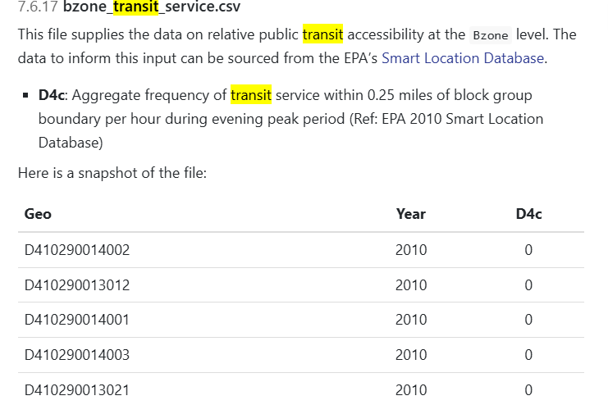
- GIS processing Block groups: D:\VE2025\BlockGroupsBZones\Align
- Smart location database is in there as D:\VE2025\BlockGroupsBZones\Align***John go here
- Old database from EPA: D:\zVE_Material\OlderJulyMaterial
- Old explanations \\501-RC-NAS1\Users\John.Miller\Current\VisionEvalNova\InputsNoGISFiles\SmartLocationDatabase\bzone_transit_service .docx
- How the GIS processing was done—old way left was ultimately better
